**(Cortex-M3, STM32F207) Mango-M32F2, Ethernet lwIP HTTP Server OK**

[**http://www.mangoboard.com/**](http://www.mangoboard.com/)

**http://cafe.naver.com/embeddedcrazyboys**

**Crazy Embedded Laboratory**

**Document History**

|  |  |  |
| --- | --- | --- |
| **Revision** | **Date** | **Change note** |
|  |  |  |
|  |  |  |

1. Release Note 2012 03 14 4

**1.1.** Base 코드 4

**1.2.** 수정사항 4

# **(Cortex-M3, STM32F207) Mango-M32F2, Ethernet lwIP HTTP Server OK**

|  |  |  |  |  |  |
| --- | --- | --- | --- | --- | --- |
| **(Cortex-M3, STM32F207) Mango-M32F2, Ethernet lwIP HTTP Server OK** | | | | | | [☞ 망고M32F2 메뉴얼](http://cafe.naver.com/ArticleList.nhn?search.clubid=15961514&search.menuid=182&search.boardtype=L&userDisplay=) |
|  | 2012.04.19 14:26 | | | [삭제](javascript:checkLogin('delete');) |

양식의 맨 위

양식의 맨 아래

|  |  |  |  |
| --- | --- | --- | --- |
| |  |  | | --- | --- | | [http://itemimgs.naver.net/personacon/58/21/1112158.gif](http://item.naver.com/personacon/PersonaconShop.jsp?Redirect=PersonaconSub.jsp?type=itemdetail%26itemseq=1112158) | [**푸우(yhoh)**](http://cafe.naver.com/ArticleRead.nhn?clubid=15961514&page=1&menuid=182&boardtype=L&articleid=17789&referrerAllArticles=false) | | 카페스탭http://cafeimgs.naver.net/levelicon/1/1_888.gif |
| <http://cafe.naver.com/embeddedcrazyboys/17789> [http://cafeimgs.naver.net/cafe4/btn-copy-add.gif](http://cafe.naver.com/ArticleRead.nhn?clubid=15961514&page=1&menuid=182&boardtype=L&articleid=17789&referrerAllArticles=false) | |
|  | |

[첨부파일(**1**)](http://cafe.naver.com/ArticleRead.nhn?clubid=15961514&page=1&menuid=182&boardtype=L&articleid=17789&referrerAllArticles=false)

HTTP Server 예제를 올렸습니다.

여러가지 바꾸어주어야 할 부분이 많네요.

하여간 성공해서 동작 시켰습니다.

|  |
| --- |
| HTTP Server Test start ...  ETH_GPIO_Config done ...  .ETH_MACDMA_Config done ...  ETH_BSP_Config done ...  LwIP_Init done ...  httpd_init done ...  Looking for DHCP server. please wait...  ETH_CheckFrameReceived ...  ETH_CheckFrameReceived ...  ETH_CheckFrameReceived ...  IP address assigned by a DHCP server 192.168.1.6 |

수행이 되면 DHCP로 IP를 받아왔습니다.

|  |
| --- |
| C:\WINDOWS>ping 192.168.1.6  Pinging 192.168.1.6 with 32 bytes of data:  Reply from 192.168.1.6: bytes=32 time=5ms TTL=255  Reply from 192.168.1.6: bytes=32 time=2ms TTL=255  Reply from 192.168.1.6: bytes=32 time=2ms TTL=255  Reply from 192.168.1.6: bytes=32 time=2ms TTL=255  Ping statistics for 192.168.1.6:     Packets: Sent = 4, Received = 4, Lost = 0 (0% loss),  Approximate round trip times in milli-seconds:     Minimum = 2ms, Maximum = 5ms, Average = 2ms |

ping도 위와 같이 잘 동작합니다.

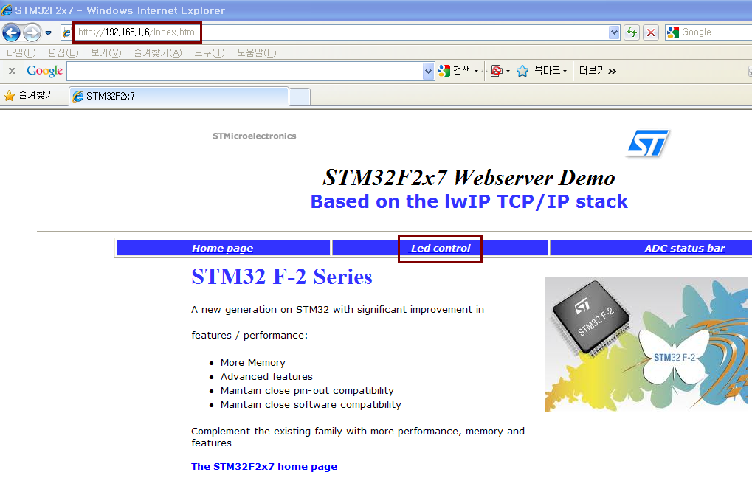

<http://192.168.1.6/index.html>

DHCP로 받아온 IP를 HTTP로 접속하면 위 화면을 볼 수 있습니다.

HTTP Server가 작동되는 모습이 참 신기하네요.

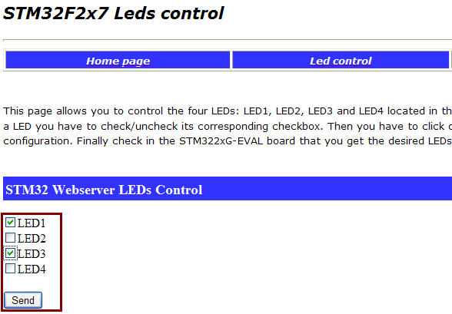

Led control을 누르면 위 화면을 볼 수 있습니다.

LED1, LED3만 선택해서 Send를 누르면 이 정보를 받아서

보드에도 LED1, LED3가 켜지는 것을 확인할 수 있습니다.

